Development log

Tuesday

Beginning of the Project. We started by creating a simple wireframe for the main page, considering the secondary pages to create for the site and the aesthetic for it. We also decided to make it adaptable for mobile viewing. After settling for a minimalist design filled with colour splashes, we started doing the HTML for the index (main page). The navbar and carousel didn’t work properly. The navbar didn’t function on mobile and the carousel didn’t change slides. We decided to fix them another day in order to focus in having the rest of the pages.

Wednesday

We continued with the index and also proceeded to start the Artists page. We focused mainly on giving a simple look, focusing more on the images by avoiding distractive colours. We delegated the information and image research between ourselves to improve our work on the pages.

We decided to keep the same navbar and footer in almost all pages in order to keep a sense of consistency between the pages. The only pages excluded would be the logins, in order to resemble the actual correspondent log-in page.

At the end we completed the Artists page without problems. We try to solve the navbar and carousel issues, but we couldn’t manage to fix them.

Thursday

We begin the Artworks and Galleries pages. We accommodated some elements in the side of the Artworks page to give a “menu[1]” to sort the different works. We also decided to change the Account part for three types of logins: a Facebook one, a Google one, and one special for the page.

We finally managed to fix the navbar and carousel by adding the js scripts at the end of the body. We didn’t add it at the beginning due to our lack of knowledge about JavaScript.

Friday

We start the various Logins and the About Us page. We mainly focused on resembling actual Log Ins from the pages. They were simple in design but a bit difficult to keep in good ratio when viewed on mobile. As of the end of the day, we practically had the website finished.

Saturday

We used this day to polish some details on the pages. We changed a few alignments and colours in the Artworks and Main page. We also added a Sign Up to the normal Log In.

Wireframe:

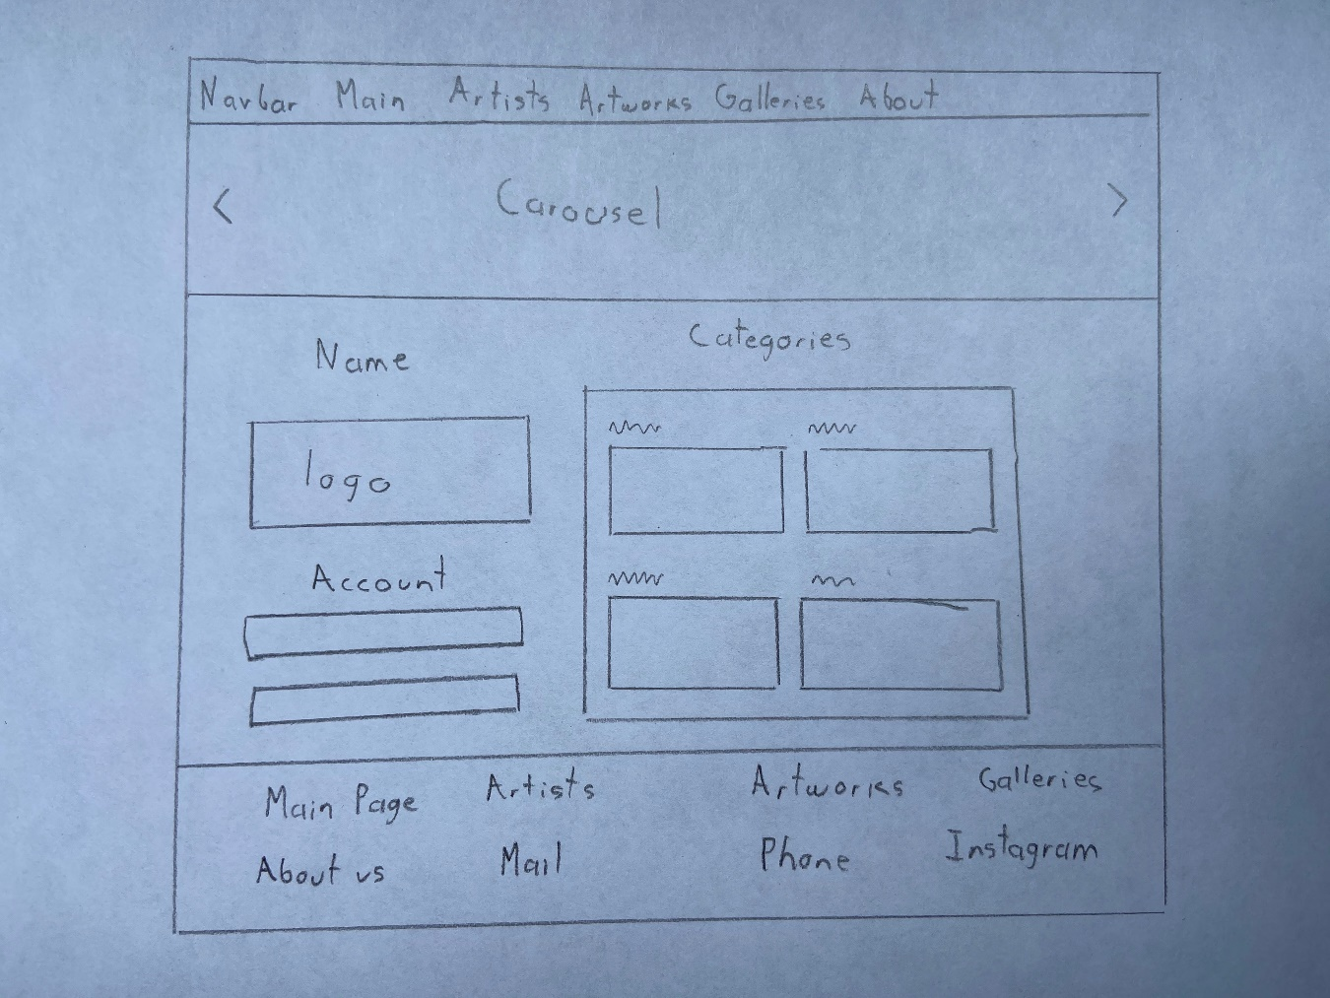

1. The menu is currently visual-only due to our lack of knowledge with JavaScript